Genuense Athenaeum



Università degli Studi di Genova

Scuola Politecnica & Facoltà di Ingegneria
_________________________________________________

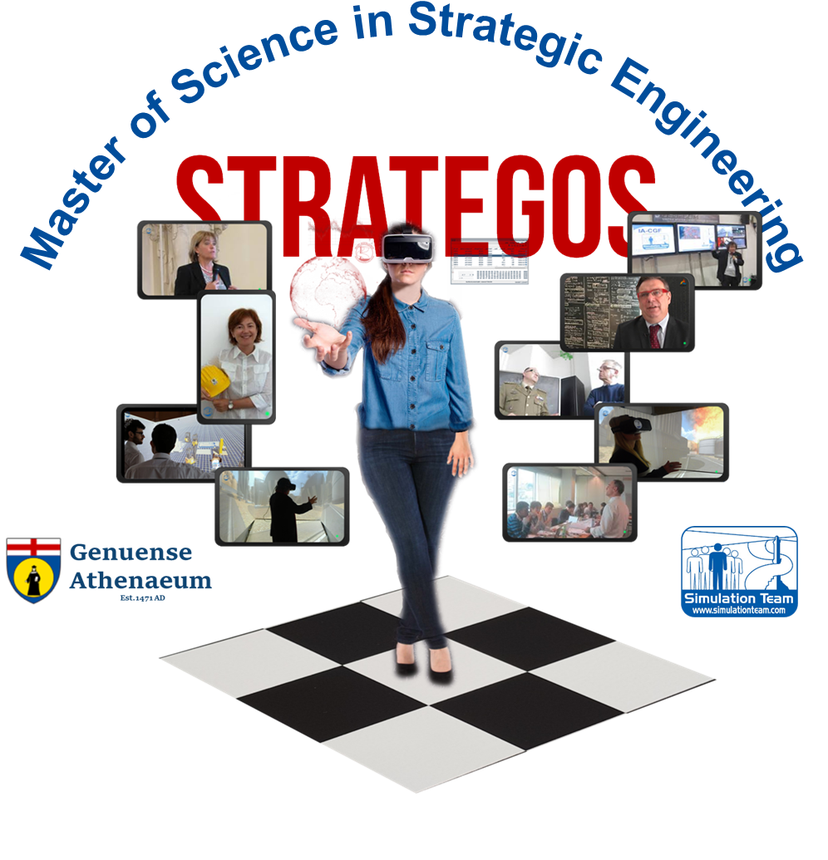
www.itim.unige.it/strategos

Laurea Magistrale in Ingegneria Strategica

International MSc in Engineering Technology for Strategy & Security

of Genoa University

_________________________________________________

[TITLE]
_______________________________________________
Advisor(s): [Prof./Dr./Mr. XXX YYY, Affiliation]
Candidate(s) : [Dr./Mr. XXX YYY]

Academic Year 2020
STRATEGOS 1st Edition
Acknowledgements

Abstract

[max 500 words]

Preface

TABLE OF CONTENTS

INTRODUCTION

[Why, What, Where this work was carried out]
CHAPTHER 1 - INDUSTRIAL CONTEXT

[The industrial context for your work in term of business sector, technical framework, engineering solutions, regulations, market, etc.]

[Text Example (please use Font Arial 10)
The Peter Kiewit Institute provide the possibility to extensively demonstrate and test models and solution for applications of simulators; and even if the Experience in Omaha R&D Center was shorter than expected, it was possible to complete the demonstration of the interoperable simulators devoted to cooperative training in industrial facilities [Bruzzone 1998]; in addition the experimentation on CUMANA Project was completed with a team of engineers in order to compare the result obtained in Seattle with Boeing. The analysis of the data was based on DOE and statistical analysis [Bruzzone, Mosca 2003; Kliem et al.1997].

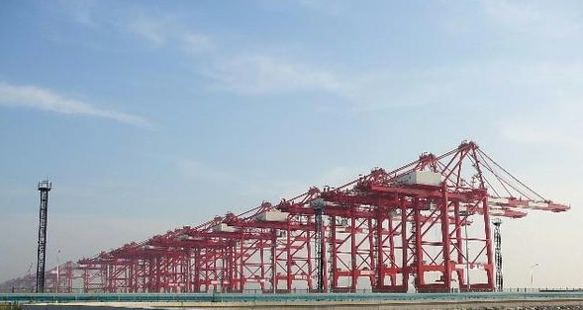
Figure 1.1:Yangshan Container Terminal subjected to Simulation Models

Table IV – Kit Distribution
Kit Distribution | %
Empenage | 1
Wing | 5
Body | 76
Body Join | 18

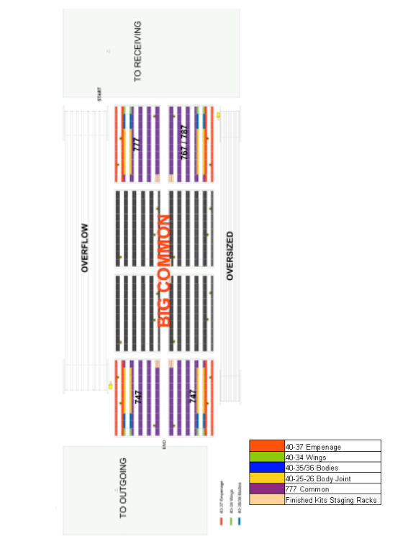
Figure 1.42:General Layout

CHAPTHER 2 - INTERNSHIP

[Internship Description]

CHAPTHER 3 – SIMULATION MODEL

[Model, Simulator, Algorithms]

In case you worked on classified or confidential data please include in the text the following sentence and act in consequence:

The following data have been modified/altered due to confidential nature of these issues
Please consider to cancel unit of measures, modify numbers and values, obscure layout and drawings, etc if it is required in order to guarantee IPR (Intellectual Proprietary Rights) and/or confidential info.
CHAPTHER X - [TITLE]

CHAPTHER X+1 - [TITLE]

CONCLUSIONS

[Synthesis of what you have done and the result achieved, benefits, gap]

LESSONS LEARNED

[What it was possible to learn on the subject of your thesis; gaps, errors, discoveries identified during this study]
FUTURE DEVELOPMENTS

[Future step forward highlighted by the current work]
TECHNICAL & SCIENTIFIC REFERENCES
[Reference to all the works that you used]
- Blackmore, S. (2006). Conversations on consciousness. Oxford University Press, UK
- Balci, O. (1997, December). Verification validation and accreditation of simulation models. In Proceedings of the 29th conference on Winter simulation (pp. 135-141). IEEE Computer Society.
- Barrat, J. (2013). Our final invention: Artificial intelligence and the end of the human era. Thomas Dunne Book, Macmillam, NYC
- Bruzzone A.G. (2018) “MS2G as Pillar for Developing Strategic Engineering as a New Discipline for Complex Problem Solving”, Keynote Speech at I3M, Budapest, September
- Bruzzone A.G., Massei M., Longo F., Maglione G.L., Di Matteo R., Di Bella P., Milano V. (2017) "Verification and Validation Applied To an Interoperable Simulation for Strategic Decision Making Involving Human Factors", Proc.of WAMS, Florence, September
- Bruzzone A.G., (2017) "Smart Simulation: Intelligent Agents, Simulation and Serious Games as enablers for Creating New Solutions in Engineering, Industry and Service of the Society. Keynote Speech at International Top-level Forum on Engineering Science and Technology Development Strategy- Artificial intelligence and simulation, Hangzhou, China
- Bruzzone A.G., Agresta M., Sinelshchikov K. (2017a) “Simulation as Decision Support System for Disaster Prevention”, Proc. of SESDE, Barcelona
- Bruzzone A.G., Massei, M. (2017b) “Simulation-Based Military Training”, in Guide to Simulation-Based Disciplines, Springer, pp. 315-361
- Bruzzone A.G., M. Massei, F. Longo, L, Nicoletti, R. Di Matteo, G.L.Maglione, M. Agresta (2015) "Intelligent Agents & Interoperable Simulation for Strategic Decision Making On Multicoalition Joint Operations". Proc. of DHSS, Bergeggi, Italy
- Bruzzone A.G., Massei M., Agresta M., Poggi S., Camponeschi F. & M. (2014) "Addressing strategic challenges on mega cities through MS2G", Proc. of MAS2014, Bordeaux, September
- Bruzzone A.G., Massei, M., Tremori, A., Poggi, S., Nicoletti, L., & Baisini, C. (2014a) “Simulation as enabling technologies for agile thinking: training and education aids for decision makers” International Journal of Simulation and Process Modelling 9, 9(1-2), 113-127
- Bruzzone A.G., Massei M., Tremori A., Longo F., Nicoletti L., Poggi S., Bartolucci C., Picco E., Poggio G. (2014b) "MS2G: simulation as a service for data mining and crowd sourcing in vulnerability reduction", Proc. of WAMS, Istanbul, September
- Cayirci, E. (2013, December). Modeling and simulation as a cloud service: a survey. In Proceedings of the 2013 Winter Simulation Conference: Simulation: Making Decisions in a Complex World (pp. 389-400). IEEE Press.
- Barth, M., Johnston, E., & Tadi, R. (1996). Using GPS technology to relate macroscopic and microscopic traffic parameters. Transportation Research Record: Journal of the Transportation Research Board, 1520, 89-96.
- Duderstadt, J.J. (2005). A roadmap to Michigan's future: Meeting the challenge of a global knowledge-driven economy, National Academy Press, Washington, D.C.
- Clymer, A.B. (1993, December). Applications of discrete and combined modeling to global simulation. In Proceedings of the 25th conference on Winter simulation (pp. 1135-1137). ACM.
- Clymer, A.B. & Mcleod, J. (1993) “Mission Earth Symposium”, Summer Computer-Simulation Conference, San Diego, July 18-20
- Clymer, A.B. (1994). " Mission Earth Symposium: World Simulation for Education”, Proc. of the National Educational Computing Conference, Boston, June 13-15
- Clymer A.B. (1980). Simulation for training and decision-making in large-scale control systems: Part 1: Types of training simulators. Simulation, 35(2), 39-41.
- Clymer, A. Ben (1969, April). The Modeling and Simulation of Big Systems. In Proceedings of the Pittsburgh Simulation and Modeling Conference.
- Clymer, M.G., & Mechoso, C. R. (1997) “Mission Earth: Modeling and Simulation for a Sustainable Global System”, Proc. of the Western Simulation Multi Conference, SCS, Phoenix, January 12-15
- Duma L., Nemeslaki A. (2013) “Of Aluminium, Recycling and the Homeless: A case study of technology driven social inclusion”, Proc. of EGPA Annual Conference, Edinburgh, September
- Elfrey P. (2006) “Moving out the Planet”, Invited Speech at Summer Sim, Calgary, Canada, July
- Fuller, R. B. (1969). The World Game. Ekistics, 286-292
- Harding J. (2018)“CCTV shows Genoa bridge collapse”, BBC News, August 21
- House, P. W., McLeod, J (1977). Large-scale models for policy evaluation. John Wiley & Sons, NYC
- Huang, G. H., Linton, J. D., Yeomans, J. S., & Yoogalingam, R. (2005). Policy planning under uncertainty: efficient starting populations for simulation-optimization methods applied to municipal solid waste management. Journal of Environmental Management, 77(1), 22-34.
- Kim, J. H. (2013) “Universal GPS traffic monitoring system”, U.S. Patent No. 8,386,157, U.S. Patent and Trademark Office, Washington, DC:
- Kuhl, F., Dahmann, J., & Weatherly, R. (2000). Creating computer simulation systems: an introduction to the high level architecture. Upper Saddle River: Prentice Hall PTR
- Li, B. H., Zhang, L., Wang, S. L., Tao, F., Cao, J. W., Jiang, X. D., ... & Chai, X. D. (2010). Cloud manufacturing: a new service-oriented networked manufacturing model. Computer integrated manufacturing systems, 16(1), 1-7
- Longo, F. (2011). Advances of modeling and simulation in supply chain and industry, Simulation, August 26
- McAfee, A., Brynjolfsson, E., Davenport, T. H., Patil, D. J., & Barton, D. (2012). Big data: the management revolution. Harvard business review, 90(10), 60-68.
- McLeod, J. (1999). Simulation as a Possible Tool for Peace. Simulation, 72(5), 348-352.
- McLeod, J., & McLeod, S. (1995) “Mission Earth And The Big Bird From The Ashes”, Simulation, SCS, vol.64, n.1, June 1
- McLeod, J. (1986). Computer modeling and simulation: The changing challenge. Simulation, 46(3), 114-118.
- McLeod, J. (1968). Simulation: the dynamic modeling of ideas and systems with computers. McGraw-Hill.
- McLeod, John & McLeod Suzette (1974) “Simulation in The Service of Society: World Simulation Organization”, Simulation, SCS/SAGE, April 1st, doi.org/10.1177/003754977402200412
- Meadows, D. H., Meadows, D. H., Randers, J., & Behrens III, W. W. (1972). The limits to growth: a report to the club of Rome (1972). Google Scholar
- Najafabadi, M. M., Villanustre, F., Khoshgoftaar, T. M., Seliya, N., Wald, R., & Muharemagic, E. (2015). Deep learning applications and challenges in big data analytics. Journal of Big Data, 2(1), 1.
- Oren, T. I., Elzas, M. S., Smit, I., & Birta, L. G. (2002, July). Code of professional ethics for simulationists. In Summer Computer Simulation Conference (pp. 434-435). Society for Computer Simulation International; 1998.
- Sanchez, S. M. (2014, December). Simulation experiments: better data, not just big data. In Proceedings of the 2014 Winter Simulation Conference (pp. 805-816). IEEE Press.
- Varaiya, P. (1993). Smart cars on smart roads: problems of control. IEEE Transactions on automatic control, 38(2), 195-207
- Wan, J., Liu, J., Shao, Z., Vasilakos, A. V., Imran, M., & Zhou, K. (2016). Mobile crowd sensing for traffic prediction in internet of vehicles. Sensors, 16(1), 88
- Wu, X., Zhu, X., Wu, G. Q., & Ding, W. (2014). Data mining with big data. IEEE transactions on knowledge and data engineering, 26(1), 97-107
- Zandin K.B. (2001) "Maynard's Industrial Engineering Handbook", McGraw Hill, NYC

CANDIDATE CURRICULUM VITAE & REFERENCES
[Include in 1 page your CV plus your reference email, URLs, linkedin links and other contacts]

