

***Master of Science on Engineering Technology for Strategy and Security***

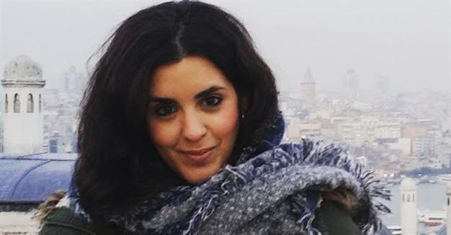

**STRATEGOS Faculty**

**Name Josepha**

**Family Name Cesare**

**Citizenship Italian & Spanish**

**Affiliation CCZT, USAS, Madrid, Spain**

**Office Address Paseo del Uruguay, 5,**

**28009 Madrid, Spain**

**Office Phone +34 444 213 1234**

**Mobile Phone +34 666 497 9876**

**Email josepha.cesare@cczt.usas.es**

**Present Position**

**Senior Lecturer at CCZT Department in University of**

**Systems and Advanced Systems in Madrid**

**Professional Experiences**

**International Faculty Member in STRATEGOS, the International Master Science in Engineering Technology for Strategy and Security (Laurea Magistrale) of Genoa University, Italy, 2020 till now**

**Senior Lecturer at CCZT, USAS in Madrid, 2018 till now**

**R&D Senior Scientists at HAL9000 in Paris, Texas, 2014-2017**

**Lecturer of Mathematical Complexity in MDT in Cambridge MA, 2012-2014**

**Scientist operating on Acoustic at NATO Center for Underwater Exploration in Halifax, Canada, 2005-2011**

**Researcher at R&D Department of Maritime Solutions of Salamanca University, 2003-2004**

**Education & Special Certificates**

**2002, PhD in Mathematical Modeling and Interoperable Simulation at Genoa University, Italy**

**2000, Master of Science in Strategic Engineering at Collodi University, Florence, Italy**

**1998, Bachelor Degree in Mathematics, , University of Chioggia, Italy**

**1995, HighSchool, Classical Lyceum Pinocchio, Saragoza, Spain**

**Scientific Experiences**

**Program Chair at Conference on Network Journeys, San Francisco, April, 2020**

**Speaker at 100 Conferences in Europe, Asia and USA**

**42 Scientific Papers on International Journals and over 160 Conference Papers**

**Projects**

**Interoperable Predictive Models based on ARIMA at CCZT**

**Autonomous Underwater Mobile Acoustic Modem at NATO Underwater Exploration Center**

**Nes FPSO Design Support Tool at University of Salamanca**

**CBRN Models at Genoa University**

**Research Interests**

* + - **Modeling and Simulation**
    - **Time Series Analysis**
    - **Forecasting**
    - **Acoustic Engineering**
    - **Autonomous Systems**

**Scientific Pubblication & Book**

**See them on www.josephacesari.es**

**Languages Italian (Native Language)**

**Spanish (Native Language)**

**English (C2 Proficiency)**

**German fluent**

**Other Experiences**

**Waitress at Restaurant Solo Ciccia at Panzano Chianti, 1999**

**Other**

**Experiences Cooking Course at Restaurant La Mi Venta in Madrid, 2019**

**I love sailing and I participate to regattas including Fastnet Race. I like movies. I am skilled in laser tag and war games. I love scuba diving in shark infested waters.**

**Useful Links** **www.linkedin.com/josepha-cesare**

**twitter.com/josephacesare**

Date ***Last Update on October 25, 2020***

***I hereby authorize STRATEGOS, Genoa University and Simulation Team to share my CV for Professional and Scientific Reasons with Companies & Institutions***