International PhD in Strategic Engineering
Genoa University

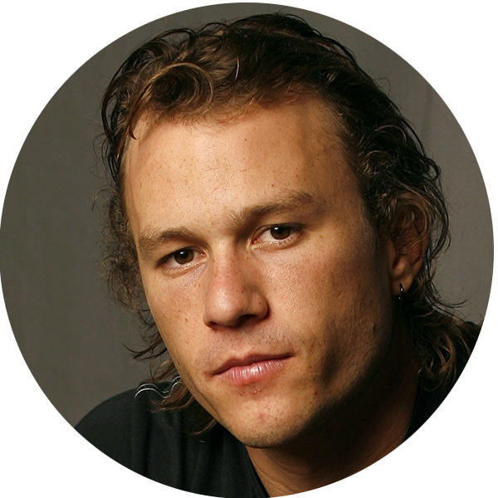
STRATEGIC Engineer Resume

Name Julius C.

Family Name Garibaldi

Citizenship Italian & Australian

Address Via Giuseppe Giusti, 7
16145, Genoa (GE), Italy

Tel +39 333 666 5642

Email julius.garibaldi@gmail.com

Skype julius.garibaldi@gmail.com
Education & Special Certificates
23 Sep 2019 – Current, University of Genoa, International Master Science in Engineering Technology for Strategy and Security (Laurea Magistrale), STRATEGOS, Genoa, Italy
October 2016-25 Apr 2019, University of Florence, Bachelor Degree in Mechanical Engineering, Florence, Italy
2010 – 2015, HighSchool, Classical Lyceum Fata Turchina, Sidney, New South Wales, Australia
Professional Experiences
R&D Manager at HAL9000 in Paris, Texas, January 2020 till now
Certificate of Successful Attendance to Hybrid Warfare Workshop, December 2019
Participation in New Silk Route Pitch Game with Genoa University and James Cook University Singapore, October 2019, 3rd Position
Office Employee for Brochure Printing for Retail Promotion at COOP in Bologna, Task: combining the products, prices and graphics for promotional material, September 2019
Group Leader for Summer School in Foreign Countries in Monaco Tour Service, London, 15 Jul 2019 – 29 July 2019 as Tutor of a team of 20 students from all over Europe during summer school in one of the most famous Guest House in London. Tasks: Organization of schedules and meetings and Social Activities
Engineering Studio for HVAC Design, Assistant, July-August 2018
Scientific Experiences
Track Chair at Conference on Network Journeys, San Francisco, April, 2020
Pending Patent on Underwater Autonomous Network System at European Patent Office
Speaker at over 20 Conferences in Europe, Asia and USA
3 Scientific Papers on International Journals and 18 Scientific Papers on Conference Proceedings

Projects
For my graduation thesis, I dealt with the theme of developing nanomaterials for filtering water and I worked with Dupont at their site in Wilmington, Delaware, USA

Other Experiences
Waiter in Summer 2017 at Solo Ciccia Restaurant, Panzano (FI), Italy

Bay Watch at Virginia Beach in August 2016

Barman in Pub at Oriental Hotel in Springwood, NSW, Australia along Summer 2016

Technical Skills
    - CAD Drawing
    - Typographical Software and Picture Elaboration
    - Basic Business Model Analysis
    - Team Working in homogeneous and not homogeneous teams
    - Fluent comunications and coordination

ICT Skills I have skills in using the Office suite with advanced skills in using Excel. I have a basic knowledge of programming languages such as C++, C#, PYTHON, MYSQL

Languages Italian (Native Language)

English (Native Language)

French (B2 Certified)

Spanish basic level

Other(s) Volunteer for the local Church activities
Ambulance Driver

Experiences Safe Driving P
I love to ski and I am pretty skilled. I read books. I am talented in Social Meme Preparation. I play splash contact games and I like to go in polygon to shoot with MG-42 and Beretta 93R. Surfer by long boards

I hereby authorize STRATEGOS, Genoa University and Simulation Team to share my CV for Professional and Scientific Reasons with Companies & Institutions

