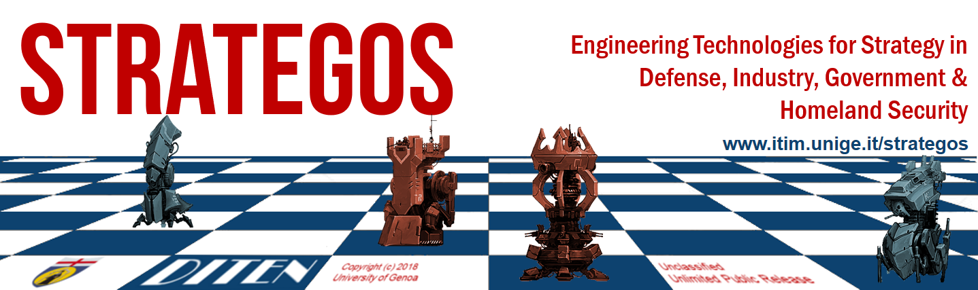STRATEGOS
Master of Science on Modelling, Engineering and Strategies on Operations and Systems
Course: Modeling and Design of Complex System
ING-IND17

Credits: 10
5 Credits for Modeling and Design of Complex Systems (M&DCS) in Industry
5 Credits for Modeling and Design of Complex Systems (M&DCS)in Defense

Tentative Schedule:
M&DCS in Industry, Bruzzone, 2nd Semester, 1st Year
Tentative Schedule 1 Lecture of 5 hours in a row per week for 8 weeks to support Class Exercises and Lab Activities as well as International Seminars

M&DCS in Defense, Bruzzone, 1st Semester, 2nd Year
Tentative Schedule 1 Lecture of 5 hours in a row per week for 8 weeks to support Class Exercises and Lab Activities as well as International Seminars

Teachers, Email & References:
Prof. Agostino G. Bruzzone, agostino.bruzzone@simulationteam.com
Col.Michele Turi (PhD in M&S), michele.turi@simulationteam.com
Ing. Federico Tarone (PhD in M&S), federico.tarone@simulationteam.com
www.itim.unige.it

Assistants for Exercises & Simulation Lab Experience:
Dott.Marina Massei, Dott.Riccardo di Matteo, Dott.Kirill Sinelshchikov, Dr.Matteo Agresta, Lt.Col.Paolo di Bella

Education Objectives:
Foundation on Complex Systems. Transfer of knowledge about Simulation Paradigms and Modeling Methodologies effective for addressing Complex Systems.. Transfer of capabilities to analyze real problems and case studies corresponding to Complex Systems. Acquisition of skills in Conceptual Modeling applied to Complex Problems. Acquisition of Skills in design of Simulation Architectures and Model Development applied to Complex Systems.
Course Program & Elements:
Introduction to the Complex Systems of the class. Definition of Complex Systems and Emergent Behaviors. Complexity Classes, Attributes, Level of Complexity. Computational Complexity, Kolmogorov complexity, Krohn–Rhodes theory, Network Complexity, Hierarchical Complexity.
Complex System Subjects: Dynamic Structures and Complex Dynamics, Complexity in Physical and Chemical systems, Biological Systems, Human Systems, Engineering and Artificial Systems. System of System Engineering and Industrial Plants as examples of Complex Systems.
Conceptual Modelling for Complex Systems. Live, Virtual and Constructive Simulation applied to Complex Systems. Challenges in Verification, Validation and Accreditation of Simulators dealing with Complex Systems.
Example of Modeling Complex Systems: Stochastic Systems, Multiparticle Systems, Multibody Systems, Models used in Systems of Systems Engineering
Examples of Simulation for different real case of Complex Systems: Case Studies related to real Industrial, Business and Defense Frameworks
Strategic Analysis and Decision Making related to Complex Systems, Design and Re-engineering of Complex Systems based on Quantitative Modelling & Simulation
Techniques for Identification and Analysis of Emergent Behaviors
Simulation Paradigms of M&S for Complex Systems; theoretical foundations of interoperable Simulation, distributed simulation, MS2G, MSaaS
Interoperable Simulation and Modelling Solution for Complex Systems
Design of Models and Development of Simulators and Federations of Simulators
Human Behavior Modeling and Intelligent Agents reproducing Population and Social Systems.
Operational Expertise in using Modeling and Simulation (M&S) and related experimental methodologies and techniques to investigate complex systems and to support related decision making processes.
Lean Simulation: Concept, Methodologies and Techniques, Modeling and Simulation applied to Early Stage Evaluation of Large Programs. Methodologies and Techniques for applying M&S in SME (Small Medium Size Enterprises).
Simulation as enabler for Applying Artificial Intelligence and Intelligent Agents in Industrial and Defense Applications: Nested and Combined Simulation to support Decision Making and Planning. Artificial Intelligence Techniques integrated with Simulation for Strategic Decision Making.
Strategic Decision Making Based on Simulation in Defense over Multiple Join Domains: M&S of Joint Operations over a Comprehensive Approach and Simulation for Transformation (e.g. Autonomous Multi Domain Systems, Hybrid Warfare, Threat Networks).
Simulation of Complex Systems in Business and Industrial Plants (e.g. MOSES, CUMANA, LEM, LEXIS, GreenLog, SISOM).
Simulation of Complex Systems in Defense and Homeland Security(e.g. JESSI, CAPRICORN, IA-CGF, IDRAS).
Direct Experiences in applying different Simulation Tools, Models, Soft Computing Intelligent Agents and technologies to address specific problems involving Complex Systems (e.g. MISCHIEF, SIMCJOH, T-REX, DT).
Experimentation and Use of Simulation Environments: e.g. LEM Simulation for Strategic Planning in Automotive Industry, MOSES Simulator for Evaluating Sustainability of new Industrial Plant into a Region. GreenLog Green Logistics Modeling. FRINE Simulation and Artificial Intelligence for Production Planning over the Supply Chain, COMADREJA Company Model for Process Reengineering, CALYPSO Life Cycle Simulation for New Carrier in Ship Building, LEXIS Industrial Plant Reorganization Simulator, CUMANA Simulation for Competitive and Cooperative Education & Training of Industrial Managers. MEGACITY Models of Development for Logistics, Safety and Energy, SISOM VR & AR for New Service Models, SECSIM Port Simulation, Logos Simulator for Strategic Planning of Fleet, Marlon SOUCI Simulation for Critical Industrial Infrastructure Protection from Physical and Cyber Threats etc.)

Teaching Approach:
Frontal Lectures presenting Theory and practical application of Methodologies related to Modelling and Simulation for Complex Systems. Individual and Team Work Exercises in developing Conceptual Models and verifying, validating, tuning and conducting experiments on Simulators of Complex Systems.
Training and Education of the Students in Virtual Experiences within Simulation Labs by using directly the presented methodologies and techniques in realistic problems and case studies using M&S solutions

Evaluation and Final Exam:
Multiple Experiences carried out in Virtual Labs where the Students are evaluated on Simulation Exercises and Experiences, based on Individual and in team working by Collaborative and/or Competitive approach, representing Micro Projects devoted to address specific issues within realistic complex problems by using M&S (e.g. MISCHIEF, SIMCJOH, T-REX, DT). Final Exam will be carried out by Oral Exam including review of the Simulation Exercises & Experiences and by requiring to demonstrate skills in conceptual modeling and simulation development.

Timetable:
To be Finalized (TBF)

Time Zone:
CET (GMT+1)

Prerequisites:
The Course does not require specific prerequisites, being accessible to University students and including all the elements and references necessary for the Candidates; therefore basics know-how in engineering, mathematics, statistics and computer use could be useful to improve the Candidate learning curve and performance.

References
Banks, J. (1998) "Handbook of Simulation: Principles, Methodology, Advances, Applications and Practice", John Wiley & Sons, ISBN 978-0471134039
Bossomaier, T.R. & Green, D.G. (2000) “Complex systems”, Cambridge University Press, UK
Bruzzone, A.G. & Massei, M. (2017) "Simulation-Based Military Training", in Guide to Simulation-Based Disciplines, Springer, pp. 315-361, ISBN 978-3319612638
Bruzzone A.G., Giambiasi N., Gambardella L.M., Merkuryev Y.A. (2001) "Harbour, Maritime & Multmodal Logistics Modelling & Simulation 2001", SCS Europe Publishing House, ISBN 90-77039-03-1
Bruzzone, A.G., Kerckhoffs (1996) "Simulation in Industry", SCS Europe Publishing House, Vol. I & II, ISBN 1-56555-099-4
Clemen R.T, Reilly T. (2001) "Making Hard Decisions", Duxbury, Pacific Grove CA
McLeod, J. (1982) “Computer Modeling and Simulation: Principles of Good Practice”, Society for Computer Simulation, San Diego, ISBN 978-9992501733
Montgomery, D.C. (2000) "Design and Analysis of Experiments", John Wiley & Sons, New York
Stern, C.W., Stalk, G. (1998) "Perspective on Strategy", John Wiley & Sons, Hoboken, NJ
Spiegel, M.R., Schiller, L.J.(1999) "Statistics", McGraw Hill, NYC
Zeigler, B.P., Praehofer, H. & Kim, T. G. (2000) "Theory of Modeling and Simulation integrating Discrete Event and Continuous Complex Dynamic Systems", Elsevier, Academic Press, ISBN 978-0127784557

